Op-Amp HW (18 points)
(jas, Op-Amp HW.docx, 10/20/2025)

Include units and clearly label answers using 3 or 4 significant digits where appropriate. Show your work so that if necessary partial credit can be awarded.

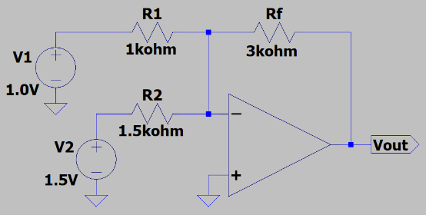
- Using KCL, determine the output voltage V_{out}, for the adjacent circuit assuming an ideal op-amp.
(3 points.)

$$V_{p}=V_{n}=0$$
$$V_{R2}=1.5 V$$
$$V_{R1}=1.0 V$$
$I_{R2}=\frac{V_{R2}}{R2}=\frac{1.5 V}{1.5*{10}^{3} kΩ}$= 1mA
$$I_{R1}=\frac{1.0 V}{1000 Ω}=1 mA$$
$$I_{R1}+I_{R2}=I_{Rf}=1 mA+1mA=2 mA$$
$V_{Rf}={-I}_{Rf}R_{f}=-(2 mA)(3kΩ)$ = -6 V
$$V_{out}=-6 V$$

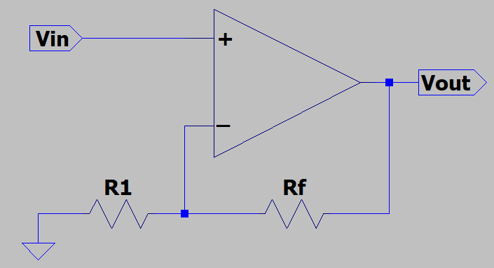
- For the adjacent non-inverting amplifier circuit assuming an ideal op-amp, calculate the value of Rf necessary for V_{out} = 5.0 V, given R1 = 10 kΩ and V_{in} = 2.0 V. (3 points.)
$V_{p}$=$V_{n}=V_{in}=2.0 V$
$$V_{R1}=2.0 V$$
$V_{R1}$=$\frac{V_{R1}}{R1}=\frac{2.0 V}{10 kΩ}=0.2 mA$
$$V_{out}-V_{R1}=V_{Rf}=5.0 V-2.0 V=3.0 V$$
$R_{f}=\frac{V_{Rf}}{I_{Rf}}=\frac{3.0 V}{0.2 mA}=15 kΩ$;
$R_{f}=15 kΩ$;

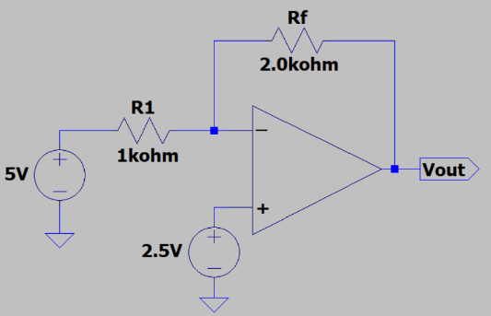
- Using the ideal op-amp assumptions for hand calculations, determine V_{out} in the adjacent circuit. (Hint: V_{out} should be < 0 V.) (3 points.)
$V_{p}$=$V_{n}=2.5 V$
$V_{R1}$=$5 V-2.5 V=2.5 V$
$$I_{R1}=\frac{V_{R1}}{R1}=2.5 mA$$
$V_{Rf}=2.5 mA*2.0 kΩ$= 5 V
$$V_{R1}-V_{0}=V_{Rf}$$
$$V_{0}=V_{R1}-V_{Rf}=2.5 V-5 V=-2.5 V$$
$$V_{0}=-2.5 V$$

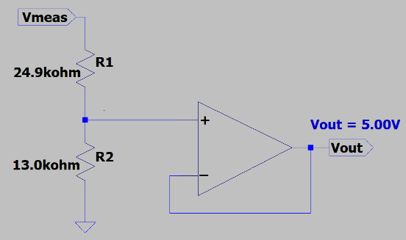
- Voltage dividers are often used to reduce larger voltages to smaller voltages that can be readily measured with microcontrollers. For this approach to work, the current through the voltage divider resistors must be the same. Yet some microcontroller analog inputs require non-negligible input current, meaning that the voltage divider output cannot be connected directly to some microcontroller analog inputs. Fortunately, a voltage follower op-amp can be used to interface between a voltage divider and microcontroller input, as the voltage follower requires negligible current from the voltage divider while providing the desired voltage and current to the microcontroller input. For the adjacent circuit assuming an ideal op-amp, calculate the voltage V_{meas} resulting in V_{out} = 5.00 V connected to a microcontroller analog input. (Hint: V_{meas} should be between 14 and 15 V.)(2 points.)

$$V_{n}-V_{p}=V_{out}=5.00 V$$
$$V_{R2}=5.00 V$$
$$I_{R2}=\frac{V_{R2}}{R2}=\frac{5.00 V}{13.0 kΩ}=0.385 mA$$
$$I_{R2}=I_{R1}=0.385 mA$$
$$I_{R1}=\frac{V_{meas}-V_{R2}}{R1}$$
$$I_{R1}=\frac{V_{meas}-V_{R2}}{R1}$$
$V_{meas}={(I}_{R1})\left(R1\right)+V_{R2}$ = (0.385 mA)(24.9 k$Ω)+5.00 V=14.58 V$
$$V_{meas}=14.58 V$$

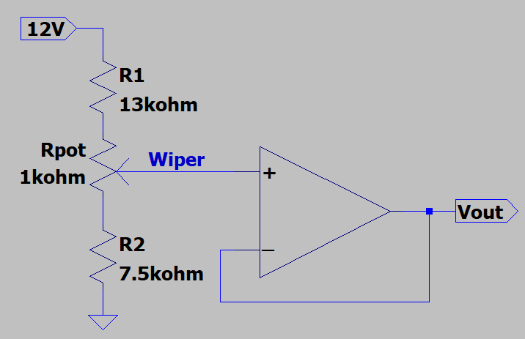
- For the adjacent circuit assuming an ideal op-amp, calculate the output voltage V_{out} with the 1 kΩ trim pot Rpot set so that the resistance above the wiper is 1 kΩ and the resistance below the wiper is 0 Ω. 9(Hint: V_{out} should be between 4 and 4.5 V.)
(3 points.)

$$V_{R2}=\frac{R2}{{R1+R}_{pot}+R2}=\frac{7.5 kΩ}{13 kΩ+1 kΩ+7.5 kΩ}=4.186 V$$
$$V_{R2}=V_{p}=V_{n}=4.186 V$$
$V_{R2}$ = 4.186 V

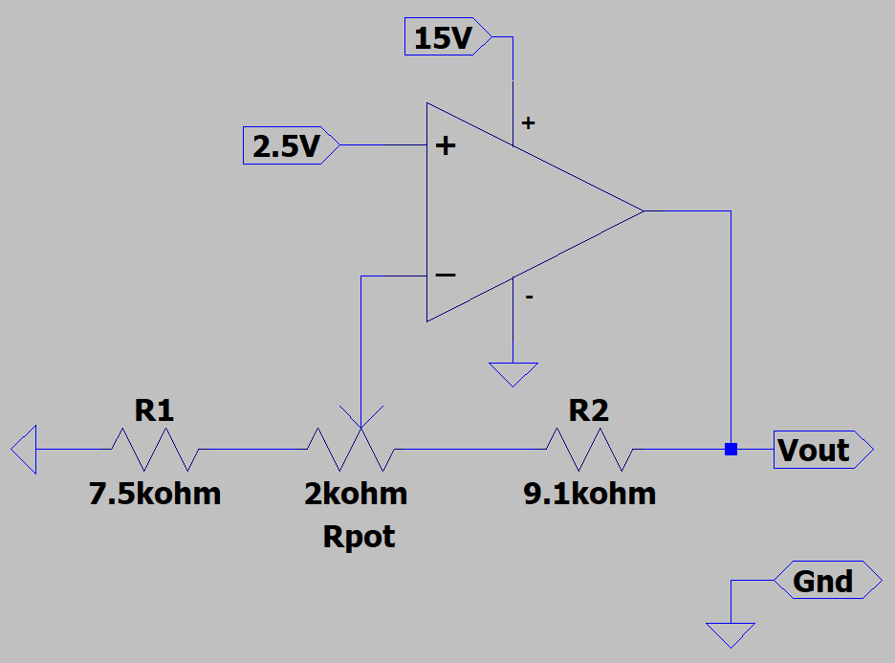
- Using the ideal op-amp assumptions for hand calculations, determine both the minimum and maximum output voltages V_{out} in the adjacent circuit. (Hint: Maximum V_{out} should be between 6.1 and 6.3 V.) (4 Points total.)

V_{out_min} = $4.893 V$ (2 points.)

V_{out_max} = $6.196 V$ (2 points.)

$$V_{n}=V_{p}=2.5 V$$

Case 1: Wiper on Rightmost Side
$$V_{Rpot}+V_{R1}=2.5 V$$
$$I_{R1}=\frac{2.5 V}{R1+Rpot}=\frac{2.5 V}{7.5 kΩ+2 kΩ}=0.263 mA$$
$$I_{R1}=0.263 mA$$
$$V_{R2}=\left(I_{R2}\right)\left(R2\right)=\left(0.263 mA\right)\left(9.1 kΩ\right)=2.393 V$$
$$V_{out}=2.5 V+2.393 V=4.893 V$$
$$V_{out_min}=4.893 V$$

Case 2: Wiper on Leftmost Side
$$V_{R1}=2.5 V$$
$$I_{R1}=\frac{2.5 V}{7.5 kΩ}=0.333 mA$$
$$I_{\left(R2+Rpot\right)}=0.333 mA$$
$$V_{out}=\left(9.1 kΩ+2 kΩ\right)\left(0.333 mA\right)+2.5 V$$
$$V_{out}=6.196 V$$

